DAY 2
Linux commands

Command 1: lscpu — Inspect CPU Information
Purpose: The lscpu command displays detailed information about the CPU architecture, processor model, logical CPUs, core topology, virtualization, cache sizes, and CPU vulnerability status.

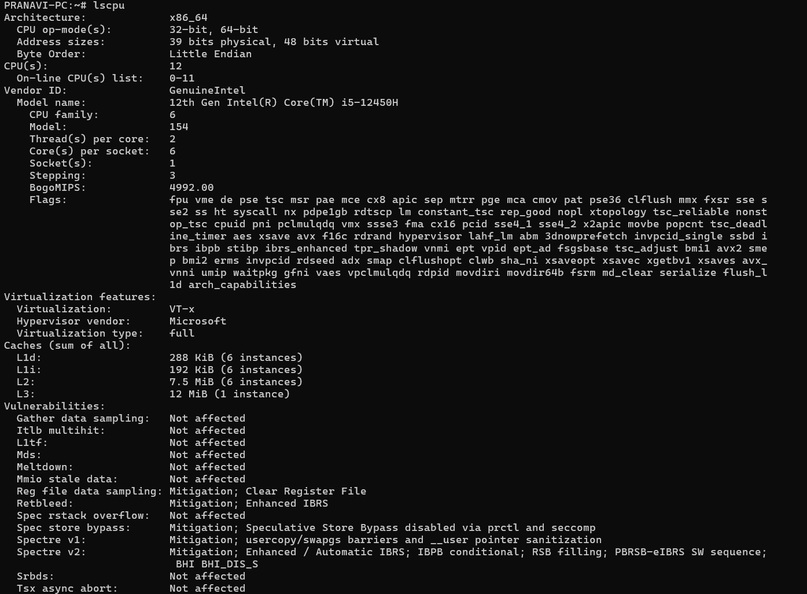

Command 2: free -h — Check Memory Usage
Purpose: The free -h command displays the system's total, used, free, and available RAM, along with swap-memory usage.

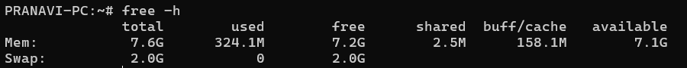

Command 3: df -h — Check Filesystem Storage Usage
Purpose: The df -h command displays the total, used, and available storage space of mounted filesystems in a human-readable format.

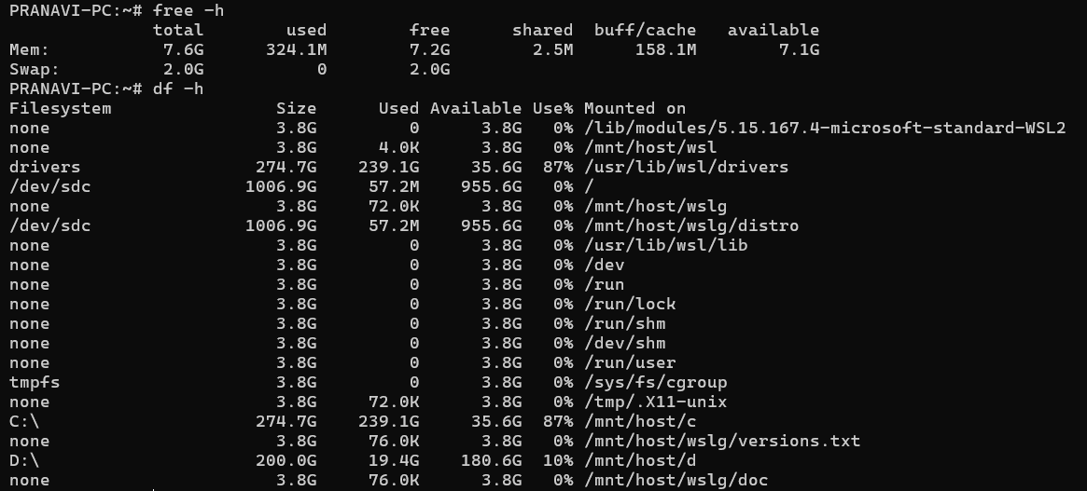

Command 4: du -sh * — Check Directory Disk Usage
Purpose: The du -sh * command estimates and displays the disk usage of each visible file and directory in the current location.
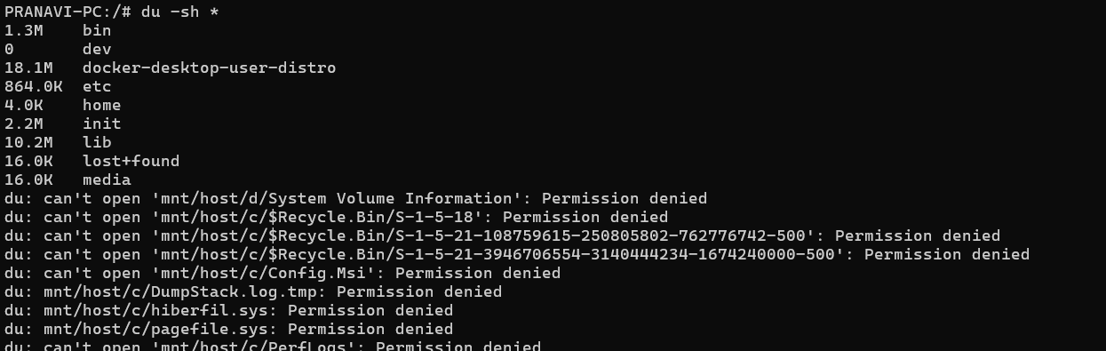
Command 5: top — Live System Performance Monitoring
Purpose: The top command displays real-time information about CPU utilization, memory usage, system load, and running processes.
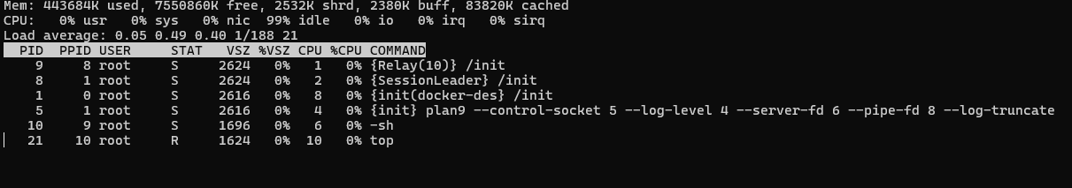
Command 6: ps — Static Snapshot of Running Processes
Purpose: The ps command displays information about currently running processes in the Linux system.
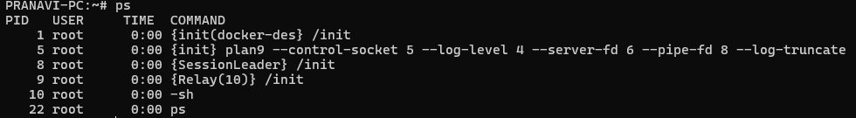

Command 7: lsblk — Inspect Disks and Partitions
Purpose: The lsblk command displays information about block devices, including disks, partitions, and their mount points.
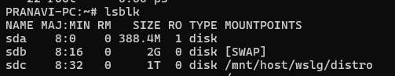
Command 8: journalctl -xe — Inspect System Logs
Purpose: The journalctl -xe command displays recent system journal entries and provides additional context to help investigate system errors and service failures.
Command 9: uptime — Check System Runtime and Load
Purpose: The uptime command displays how long the Linux system has been running, the number of user sessions, and the average system load over the last 1, 5, and 15 minutes.

Command 10: history — View Previous Terminal Commands
Purpose: The history command displays previously entered commands recorded by the current shell session.
